9.95: a) With respect to O, each element 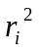 in Eq. (9.17) is 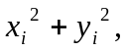 and so

b) Two perpendicular axes, both perpendicular to the washer’s axis, will have the same moment of inertia about those axes, and the perpendicular-axis theorem predicts that they will sum to the moment of inertia about the washer axis, which is 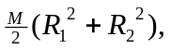 and so 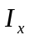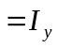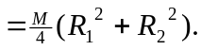
c) From Table (9.2), 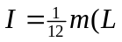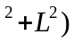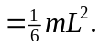
Since